## Optical Flow Algorithm:

Topic under consideration: **Face Mask Tracking**.

# **1. Introduction:**

As a part of optical flow algorithm study, I have created a video file where the person wearing mask in moving horizontally, vertically while wearing the mask and eventually takes off the mask. This is our input file under consideration. Experiment 3 is done on live webcam video. Lucas-Kanade Optical Flow algorithm is used in all the below experiment Results from all the three algorithms are given under each sub headings.

# **2.1 Experiment 1:**

**Initial Position:**

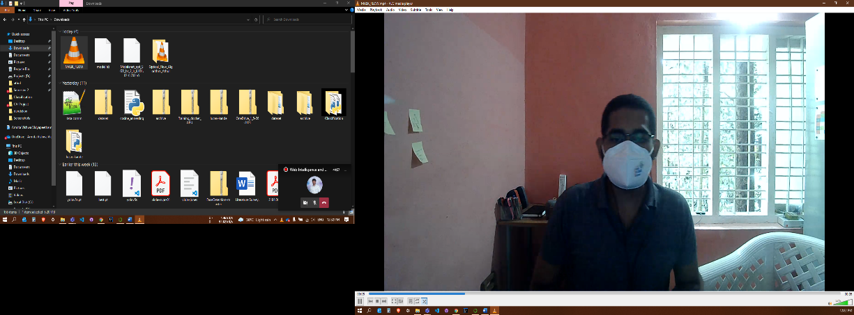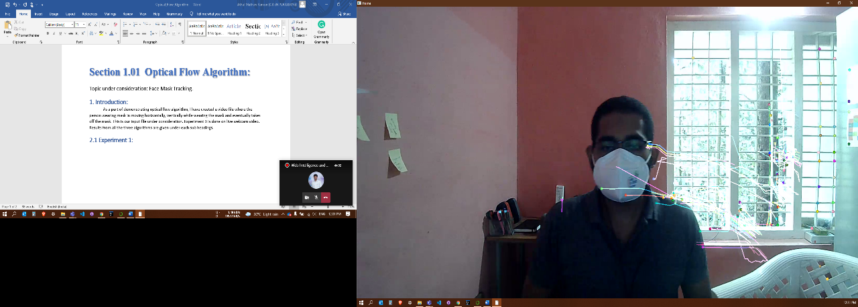

**Input Output**

**Moving Left:**

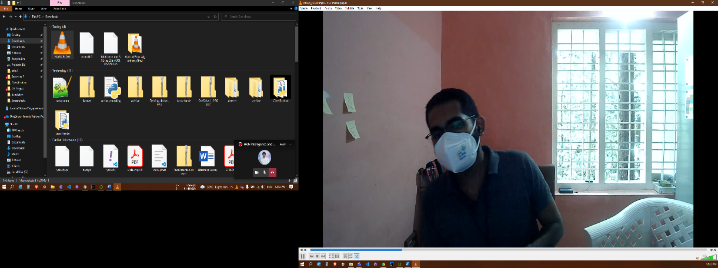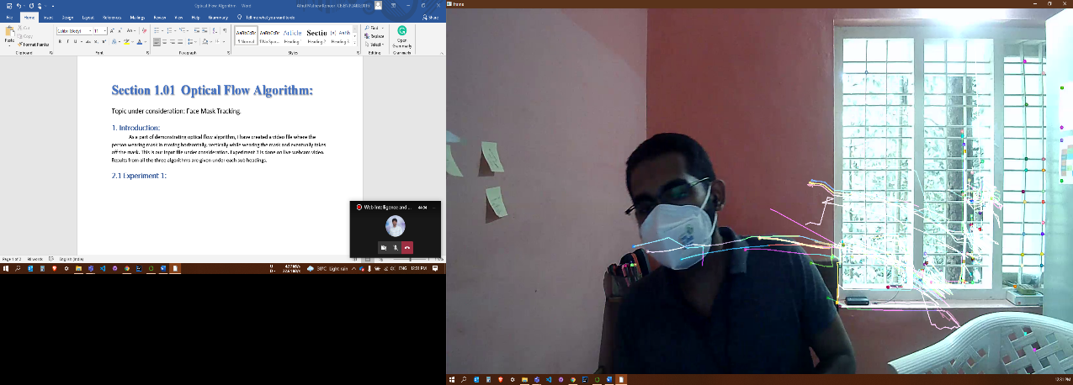

**Input Output**

**Moving Up:**

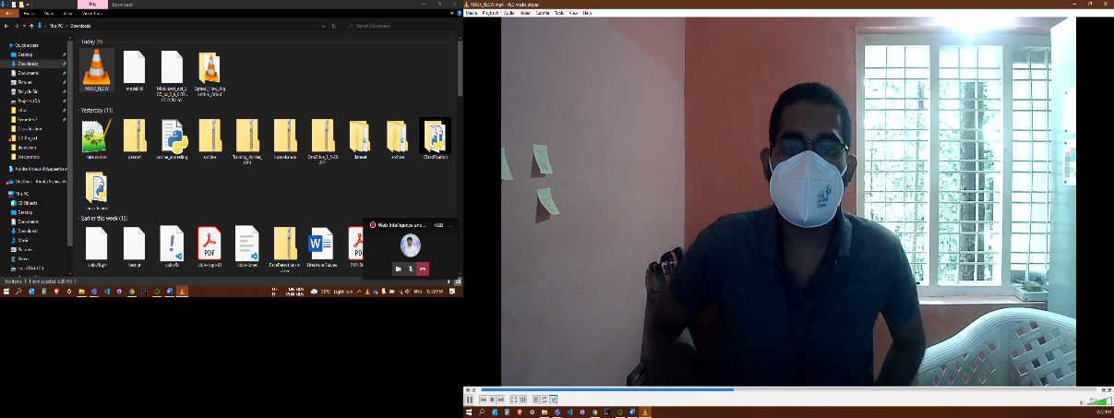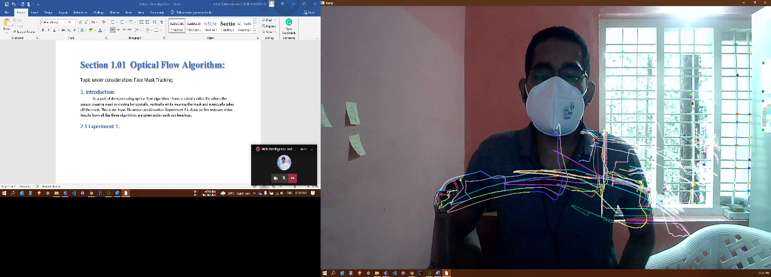

**Input Output**

**Taking Mask off:**

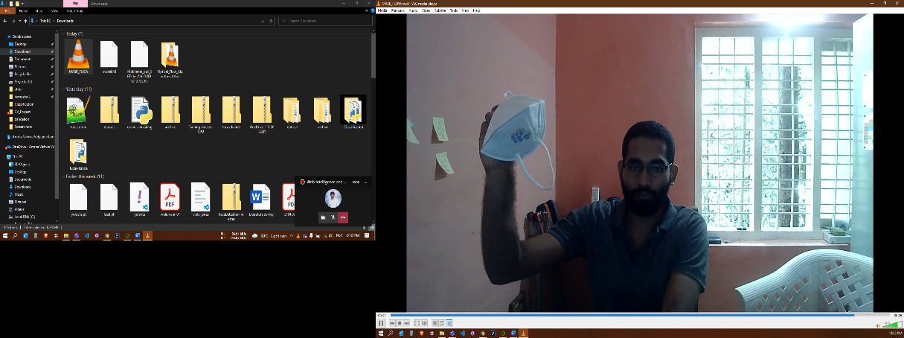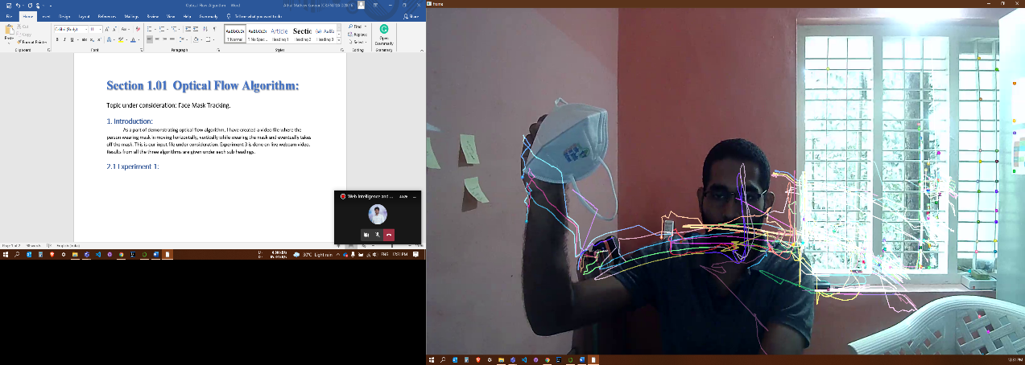

**Input Output**

# **2.2 Experiment 2:**

**Initial Position:**

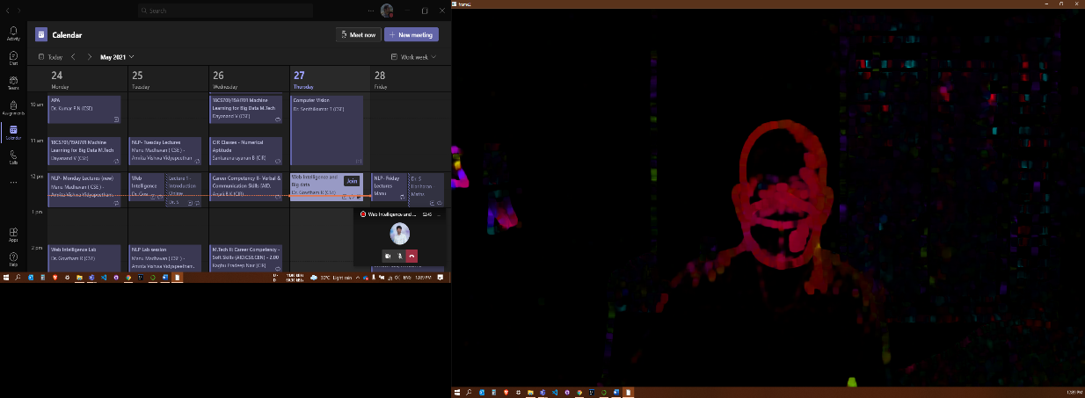

**Input Output**

**Moving Left:**

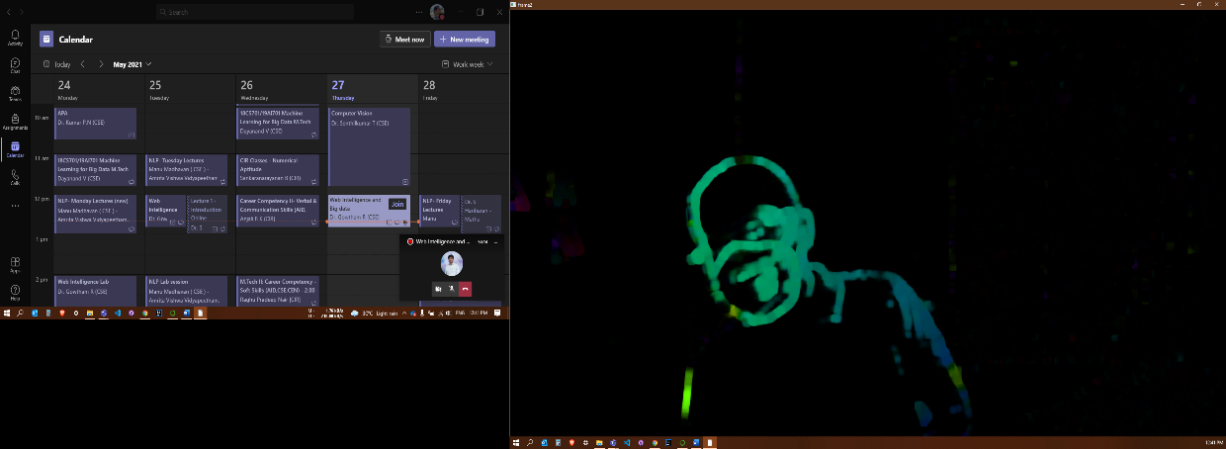

**Input Output**

**Moving Up:**

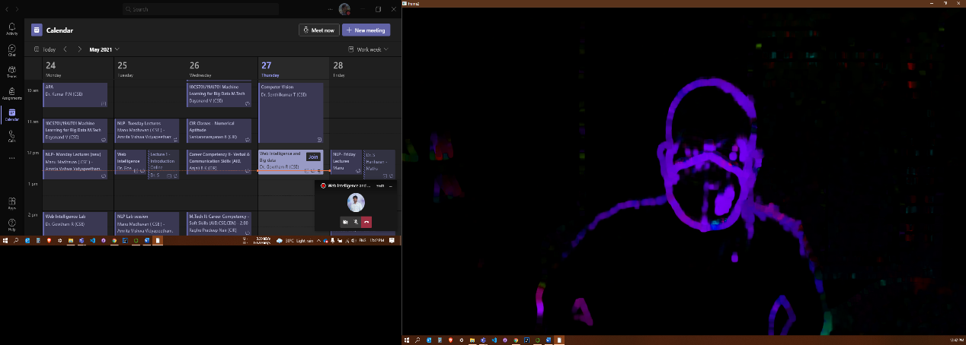

**Input Output**

**Taking Mask off:**

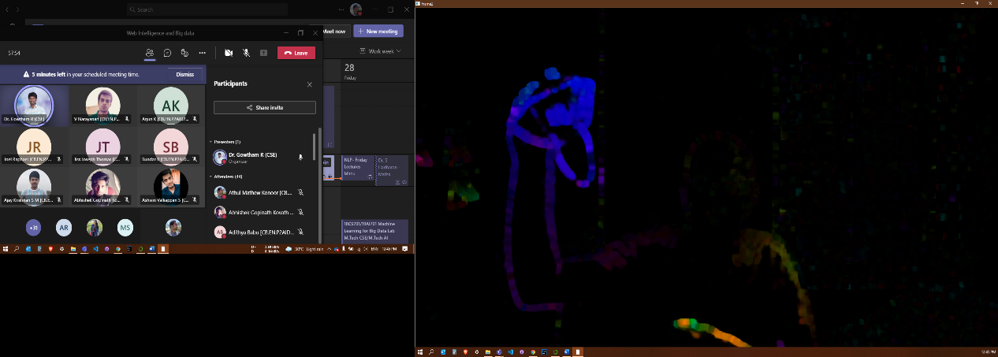

**Input Output**

**2.3 Experiment 3:**

Consecutive Sample Frames:

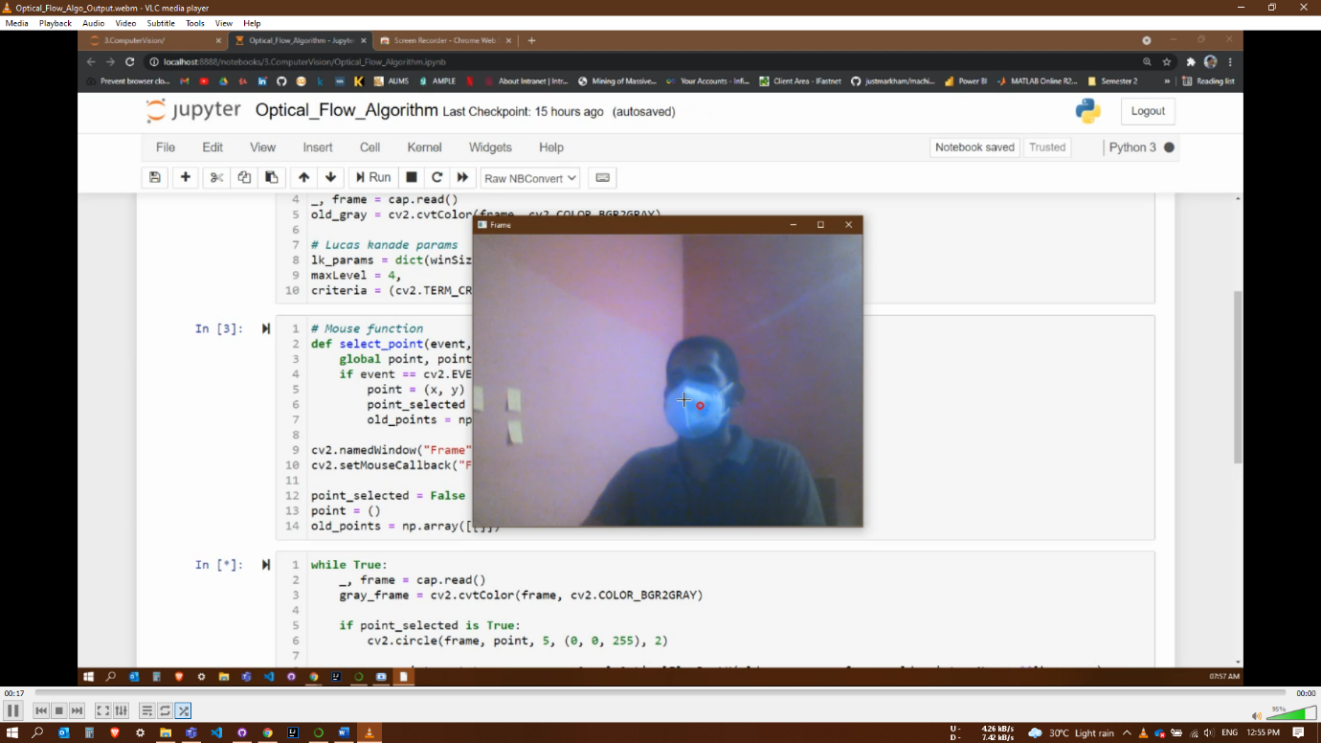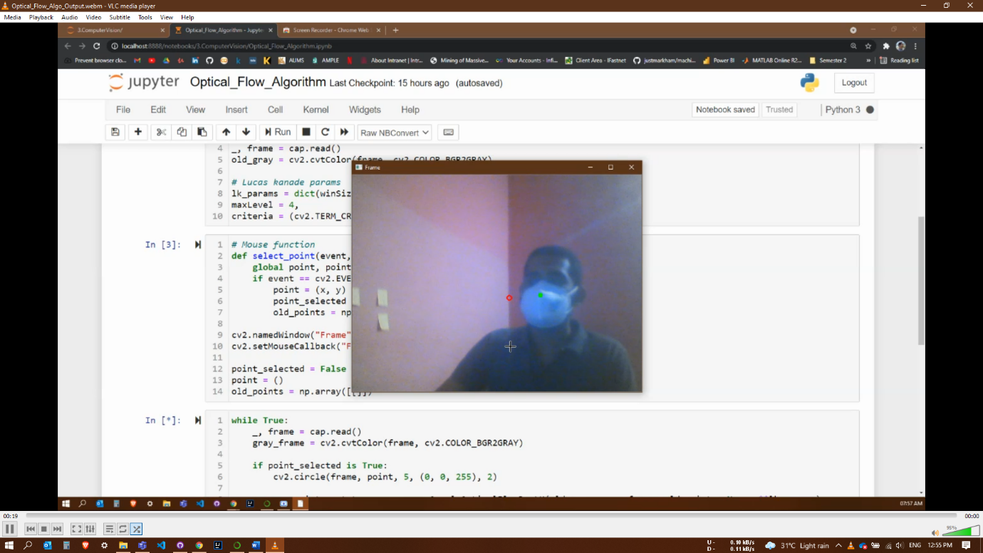

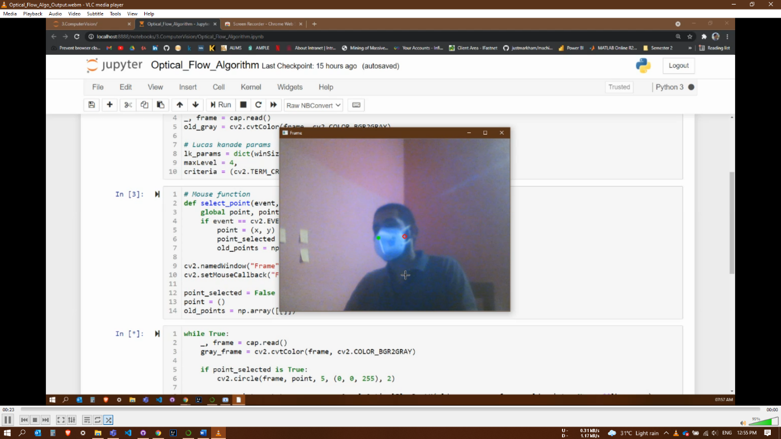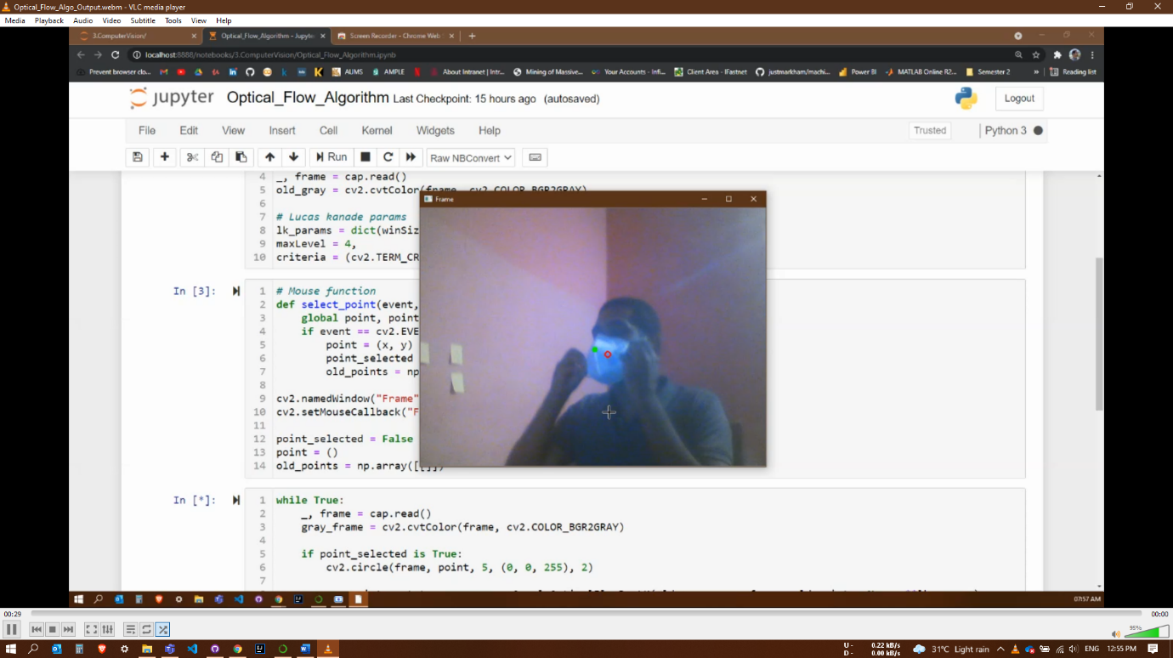

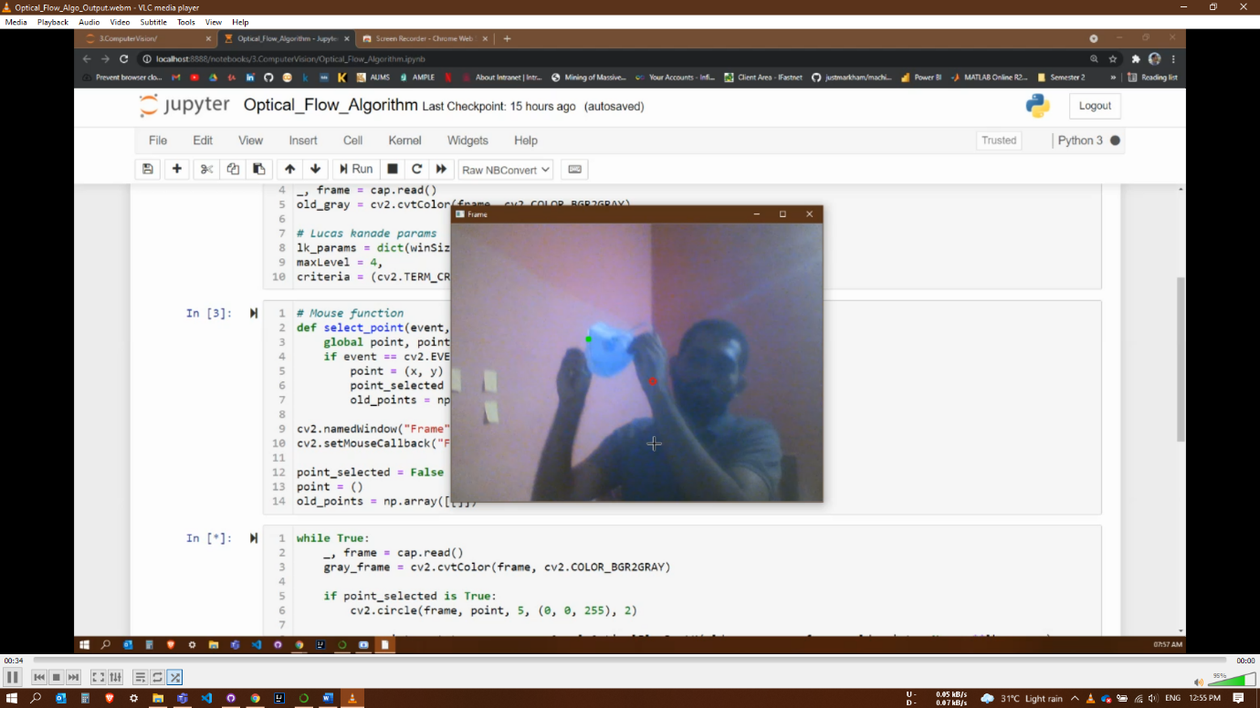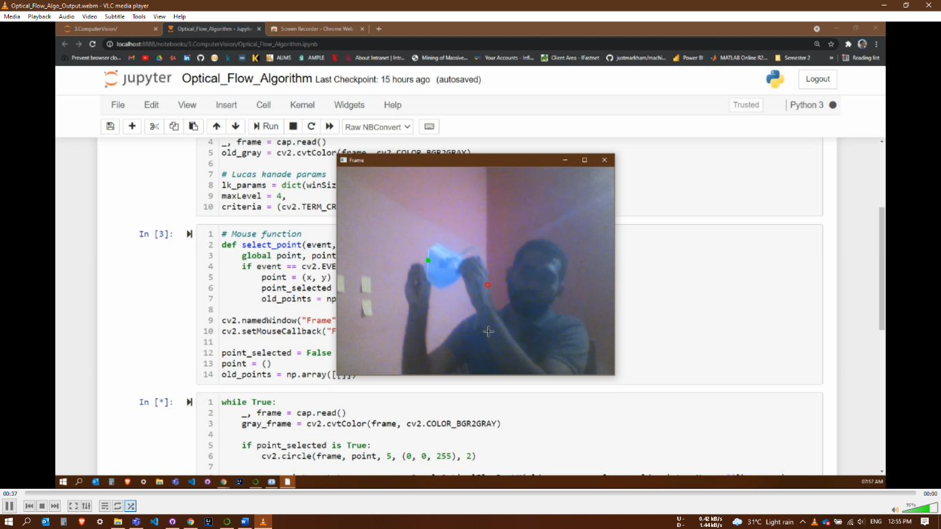

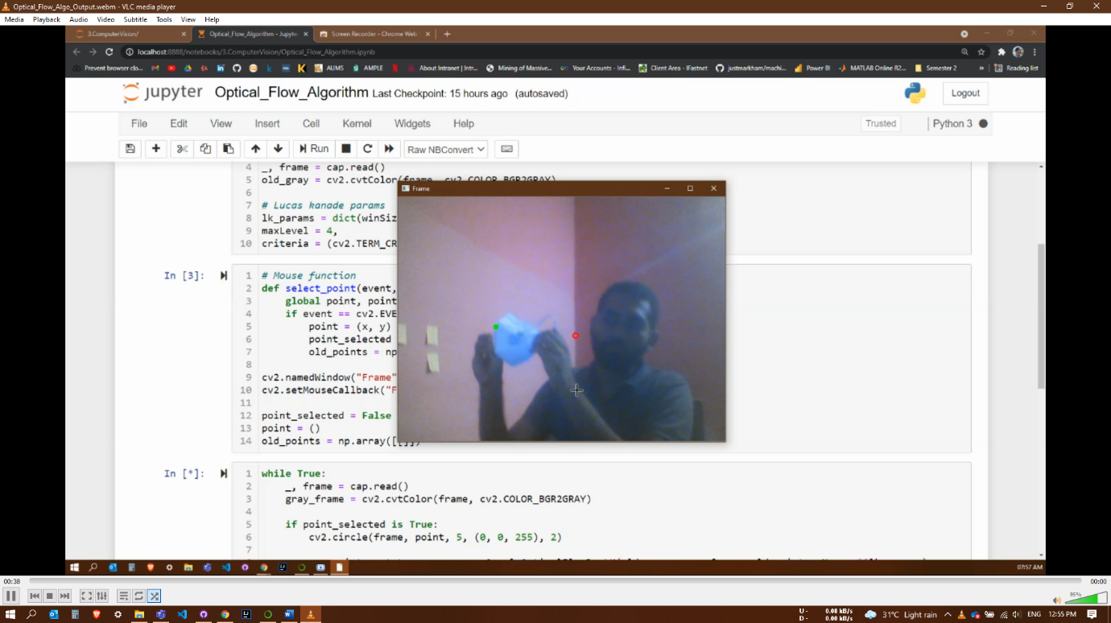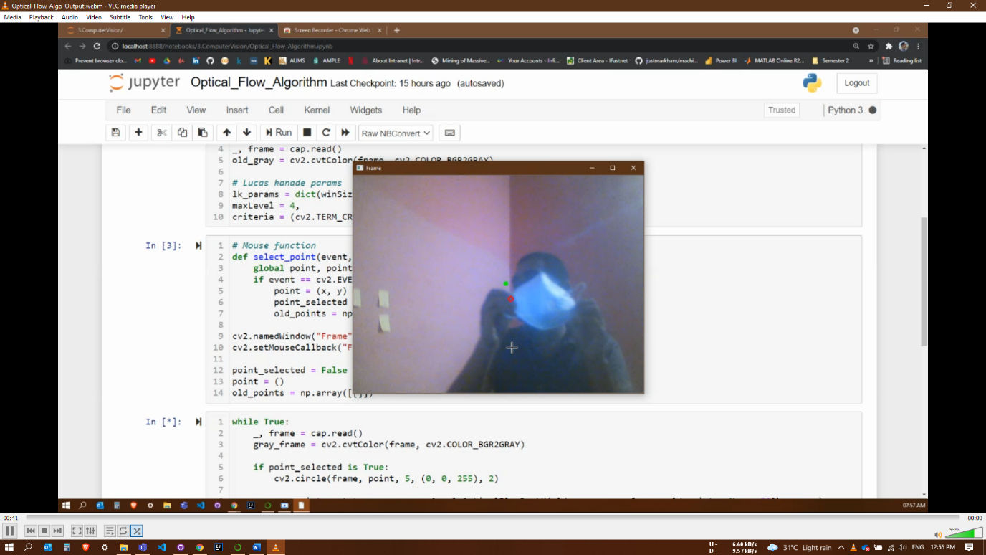

The above images show consecutive frames in the web cam feed where the white mask is being tracked (Green-dot) while the person moves left and taking the mask off.

Note: Orange arrow is used for better visibility of the green-dot.

# **3. References:**

* Lucas-Kanade Optical Flow in OpenCV : <https://docs.opencv.org/3.4/d4/dee/tutorial_optical_flow.html>

# Optical Flow with Lucas-Kanade method : <https://pysource.com/2018/05/14/optical-flow-with-lucas-kanade-method-opencv-3-4-with-python-3-tutorial-31/>

***All the code and input video used in the study is available in my GitHub Repo:*** <https://github.com/toshihiroryuu/Optical_Flow_Algorithm>

***Output of Experiment 3 is available in the Google drive link:*** <https://drive.google.com/file/d/1hVl7E4Sz2F_16Lt4oPuVHT5add_FupCP/view?usp=sharing>